NGƯỜI DÙNG

QR CODE

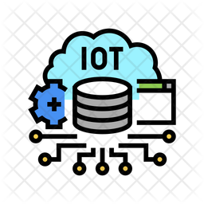

TRẠM SẠC XE ĐIỆN

IOT SERVER

HTTP/MQTT

ĐIỆN

BỘ SẠC ĐIỆN

XE ĐIỆN

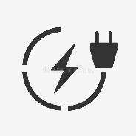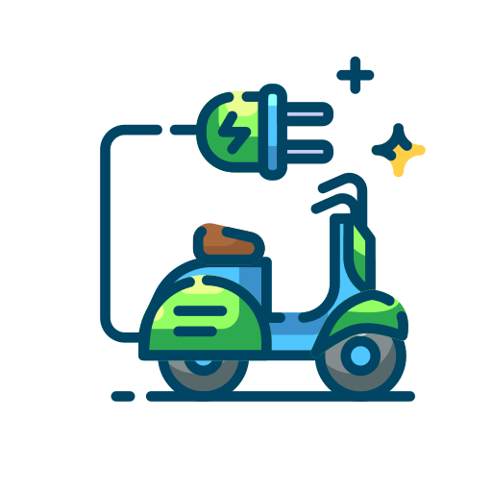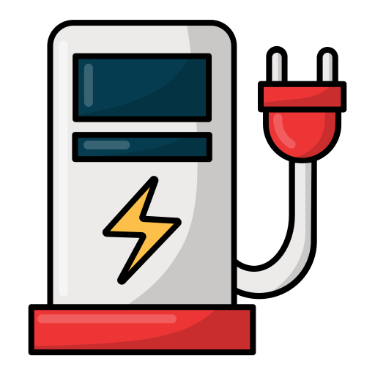

Giao thức mạng

IOT SERVER

